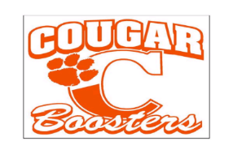
Jesse Carson Booster Club Scholarship Application
The JCHS Booster Club is proud to be able to help young athletes succeed in their academic pursuits. All student athletes are eligible regardless of the sport they engage in. The JCHS Booster Club Scholarship is awarded to the senior athlete who best exemplifies effort, dedication, commitment and spirit regardless of position on the team. It recognizes the athlete who the team could count on to give his or her best effort at practice, pitch in to help with team needs, encourage teammates to excel, but not necessarily the star of the team or even a starter.
The announcement for the JCHS Booster Club Scholarship will be made each year just prior to the annual Senior Awards Night. Please refer to the first sheet of the application form for the application deadline. The specific application due date will be announced each year well in advance. Applicants must return completed packets to the high school Guidance Office by the published deadline.
A JCHS Booster Board Officer will contact the winner.
Additional requirements for nomination:
- Be presently a senior and have participated in athletics at JCHS.
- Plan to attend a college, university or trade school following graduation.
- Exhibit both school and community involvement
- Minimum of 2.5 GPA
- No athletic suspensions
- Complete an application packet consisting of:
  - A scholarship application form,
  - One letter of recommendation from a high school varsity coach or teacher/Administrator
  - Brief summary of your career goals, special interest or hobbies listing any honors or awards received plus any other information that the application believes would offer the Carson Booster Club scholarship committee further insight into your life, values and aspirations. Please attempt to limit your responses to the space provided on the application.

For Office Use Only
No. Date:

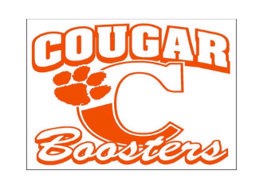

Your completed application package consisting of: Application, One letter of recommendation and summary must be submitted to the school Guidance Office by April 7, 2017.

Please sign upon completion of the application to attest to its accuracy:

Name: __________________________________________
Address: __________________________________________
Phone: __________________________________________
Student ID: __________________________________________
Parents Name (s); __________________________________________

School/College/University you are
planning to attend: __________________________________________
Address of School: __________________________________________
Have you been accepted? ___Yes ___No
Major or career field __________________________________________
High School overall GPA __________________________________________

Have you been awarded any other scholarships? __Yes __No
*If so, what is the total amount of scholarship funds you
have been awarded? __________________________________________

Applicant Signature: __________________________________________
Date: __________________________________________
Parent Signature: __________________________________________
Date: __________________________________________

*Please note that if you have been awarded full scholarships by other organizations you may not be eligible for the JCSH Booster Club Scholarship.

**Please be assured that all applications are treated in confidence. During screening the cover page will be removed and numbers will be used for identification.

For Office Use Only
No. Date:

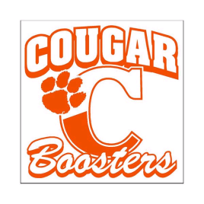
Letter of Recommendation

Each applicant must submit (1) one letter of recommendation from a high school varsity coach or teacher/administrator. This letter must be submitted with the application packet in a sealed envelope.

Coach/Teacher/Administrator information:
Name:____________________________________________________________________________________
Title/Position:______________________________________________________________________________

Write a brief statement of the applicant’s general character and integrity. Please cite the specific examples of how the applicant demonstrated the following qualities: initiative, effort, dedication, commitment and spirit. Please omit the applicant’s name from the statement.

The scholarship application deadline is April 7, 2017
Please return the completed form to the student in a sealed envelope.

For Office Use Only
No. Date:
Part II – Athletic and Extra Curricular Activities (Please provide the following information in the space provided).

1. List your Athletic/Team Participation while a student at Jesse Carson High School.

2. What extracurricular activities, including community service were you involved with during your high school years?

3. From the lists above, what accomplishments are you most proud of? Why?

For Office Use Only
No. Date:

4. Please tell us about your high school experience. In what interests, activities, groups, clubs, etc. have you been involved during your four years of high school. We would also like to know how you have displayed good sportsmanship and integrity on and off the field.

For Office Use Only
No. Date:

