Outstanding Career and Technical Education Student
Scholarship Application
Rowan-Salisbury School System

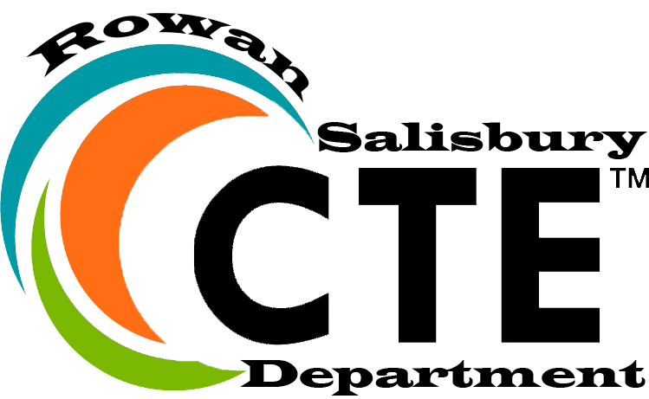

Scholarship Requirements:
- Be a senior eligible for graduation
- Possess a minimum of a 2.5 GPA
- Have completed a 4 course concentration in a career cluster

Components of the Application Process:
- Submit a completed application to your school’s Career Development Coordinator
- Participate in an interview with district staff

The completed application must be turned into the Career Development Coordinator (CDC) by Friday, March 17th and interviews will occur on Friday, MArch 24th to be scheduled by your CDC.

(application follows)
Outstanding Career and Technical Education Student
Scholarship Application
Rowan-Salisbury School System

Student Name:
High School: Grade Level:
Home Address:
(Street Address)

(City, State, Zip)
Telephone: Date of Birth:

CTE Courses Completed and/or Currently Enrolled:

Extracurricular Activities (please include any leadership experiences):

Honors and Awards (school, work, community):

(continues)
Describe your post-secondary plans and how you will apply your Career and Technical Education training to these plans:

Think about your Career and Technical Pathway experiences (equipment used, skills obtained, etc.). What projects or experiences have seemed most interesting or most important to you and why?

(continues)
Describe what you have learned about the following:
A) Teamwork

B) Problem Solving

C) Use of Tools and/or Equipment

D) Quality Work and/or Craftsmanship

Signature of Student Date

Public Notice:
In compliance with federal law, the Rowan-Salisbury School System administers all educational programs, employment activities and admissions without discrimination because of race, religion, national or ethnic origin, color, age, military service, disability, or gender, except where exemption is appropriate and allowed by the law.

