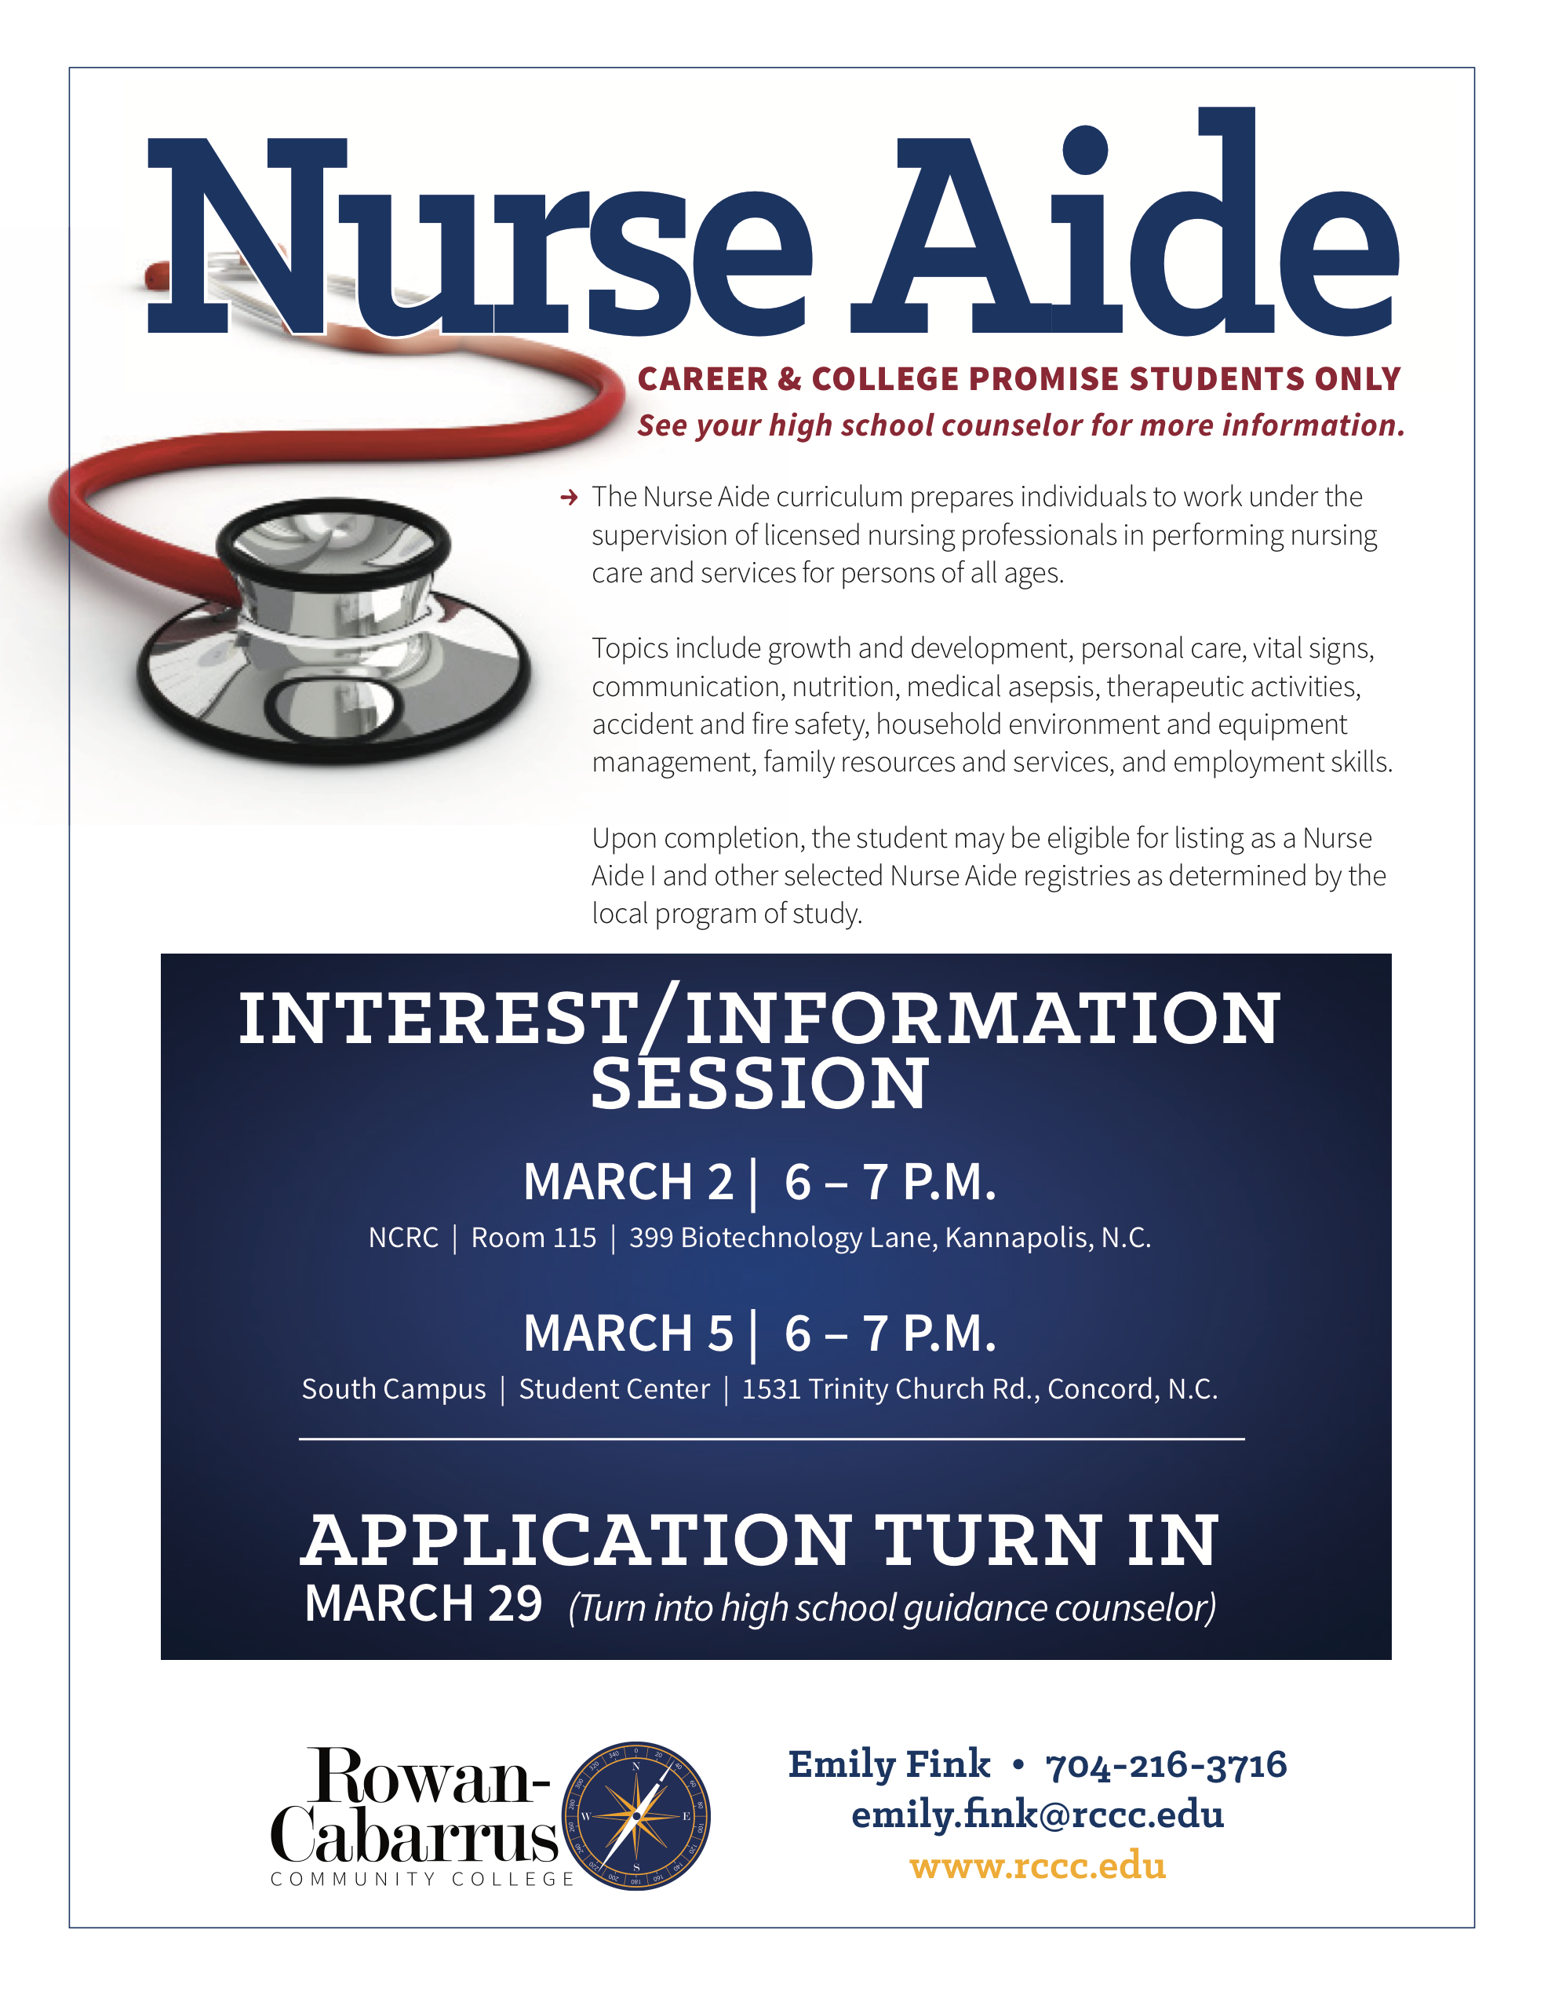TABLE OF CONTENTS

Career and College Promise
Nurse Aide Certification Information Packet

- Career and College Promise – Nurse Aid Certificate Program (C45840)…..…………………….2
- Statement of Policy – Criminal Background/Drug Screen.…….……….....……………………..4
- Program of Study.…………………………………………….…………………….….....................5
- Course Descriptions.………………………………………….……………….…….……………….6
- Competency Standards – Progression Policy.……………..…………..…………………….........7
- Attendance Requirements……………………………………………….………………………….9
- Admission Selective Point System…………………………………….….………………………..11
- Guidance Counselor Reference Form.………………………………….………………….............12
- Essay Rubric………………………………..……………………………….…………………….…..13
- Summation of Total Points……………………………………………….….…………………..….14

CAREER AND COLLEGE PROMISE
Nurse Aide Certificate Program C45840P

The Nurse Aide curriculum prepares individuals to work under the supervision of licensed nursing professionals in performing nursing care and services for persons of all ages.

Topics include growth and development, personal care, vital signs, communication, nutrition, medical asepsis, therapeutic activities, accident and fire safety, household environment and equipment management, family resources and services, and employment skills.

Upon successful completion, the student will be eligible to test for listing as a Nurse Aide I.

Program Requirements:

In addition to the general enrollment process for Rowan-Cabarrus Community College, Career and College applicants being considered for admission must meet the following requirements:

- Attend one Nurse Aide Certificate Program Information Session (2 sessions offered)

- All applicants will be required to sign in. Failure to do so will delay your admission process. At the end of the information session, all applicants are required to complete and sign the Statement of Understanding Regarding Acceptance for Clinical Training. The clinical training statement pertains to submission of a required criminal history report and mandatory 12-panel drug screen. Please realize that for admission into the program, a criminal background check (CBC) and drug screen are required. Negative clearance from either report may prevent students from participating in clinical practice (which means that they cannot complete program requirements).

High School Requirements:

- Be a high school senior;

- Have an unweighted GPA of 2.8 or higher on high school transcript;

- Provide a high school counselor reference on the form provided. The reference must be in a sealed envelope and have the school counselor’s signature on the seal.

- Complete a short answer response in 6-8 sentences that focuses on the following topic: What are your career goals and how will the Nurse Aide certificate will help you achieve your goals?

- Short answer responses should be typed using 12 pt. Times New Roman font and double spaced.
- The rubric included in this packet will be used to evaluate short answer responses.

Nurse Aide Certificate Program Point System Evaluation and requirements
The point system is an objective means for evaluating nursing applicants. Fifty percent (50%) of an applicant’s total points will come from the applicant’s GPA, Guidance Counselor reference form. Fifty percent (50%) of total points will come from the Student Essay Score (see rubric).
- Nurse Aide Certificate applicants will be ranked based upon points earned, and the students with the highest number of points will be selected. If two or more students have the identical point count total, the GPA will be the deciding factor.

- Program admission will be determined based on the applicants meeting the above program requirements. Twenty (20) applicants with the highest point totals will be admitted to the RCCC Nurse Aide Certificate Program. Contingently accepted applicants will be notified.

Full acceptance/admission into the Nurse Aide Certificate Program is not granted until the applicant completes the following:

- Required attendance at the Health Orientation session at NCRC. Date and time will be announced. At the Health Orientation session, the applicant will be given directives on completing the admission data and health packet which will include: immunizations, physical examination form (exam within the last 6 months) personal health history, criminal background check, (CBC) and mandatory drug screen and demographic information. Cost of CBC and drug screen will be announced.
- If problematic physical, or mental health conditions exist, faculty may require timely medical reports from the student’s physician confirming that the individual is physically and mentally competent to enter, or continue in the Nurse Aide Certificate Program.
- Mandatory attendance is required to a Nurse Aide Certificate Program Orientation Session. Dates and times of orientation session will be announced.

Statement of Policy, Criminal Background/Drug Screen
Nurse Aide Certificate Program, Rowan-Cabarrus Community College

Clinical facilities require criminal background checks and 12-panel drug screening for students assigned to their facility for clinical education. In addition, national and/or state registry and licensure boards may prohibit eligibility for registry or licensure based on criminal background records.

The Nursing Education Program utilizes one or more of these clinical facilities for clinical education. Therefore, to successfully complete the requirements of the Nursing Programs clinical training, each student is required to complete the criminal background and drug screening.

The criminal background check and drug screening are administered by a third party vendor who will send the results directly to the clinical agencies. After the student completes the requirements of the facility to which he/she is assigned, the clinical agency will notify the College if a student will not be allowed at the site due to a finding on the criminal background check or drug screen. Specific information about the finding will NOT be disclosed to the College.

If a student is denied access to a clinical facility based on criminal background check and/or drug screen, the student will NOT receive a secondary placement in another facility. The student will not be able to progress in the program due to the inability to meet the clinical objectives.

- I understand that pre-admissions 12-panel drug screening and a criminal history report are required for placement with “clinical training sites” for Rowan-Cabarrus Community College (RCCC).

- A criminal history report dating back seven (7) years and a pre-admission 12-panel drug screening will be included in the health packet for contingently accepted students.

- Failure to supply this information will prevent enrollment into the program.

I verify that I have read and fully understand the foregoing statement prior to my admission into the Nurse Aide Certificate Program and that I have executed this agreement of my own free will and volition without any compulsion or coercion whatsoever.

(Student Signature) RCCC Student ID #

(Print Name) Date

Nurse Aide Certificate Program

Verification of Attendance at Nursing Information Session
Date received: ______________ Signature: _______________________________

Revised: 3/2014

Nurse Aide Certificate Program, Program of Study
Career and College Promise C45840P

Major Requirements (12.0)

Required Courses | Class | Lab | Clinical | Credit Hours
Fall Semester – 2020
NAS – 101 Nurse Aide I | 3.00 | 4.00 | 3.00 | 6.00
*MED-130 Admin Office Proc I | 1.00 | 2.00 | 0.00 | 2.00
Spring Semester – 2021
NAS – 102 Nurse Aide II | 1.00 | 2.00 | 6.00 | 6.00
**PSY – 150 General Psychology | 3.00 | 0.00 | 0.00 | 3.00
TOTAL CREDIT HOURS |  |  |  | 17.00

*Online
**Online or seated

Revised 1/14/20 KA

Rowan-Cabarrus Community College
Nurse Aide Certificate Program
Course Descriptions
NAS-101 – Nurse Aide I
This course includes basic nursing skills required to provide safe, competent personal care for individuals. Emphasis is placed on person-centered care, the aging process, communication, safety/emergencies, infection prevention, legal and ethical issues, measurements, elimination, nutrition, basic restorative care/rehabilitation, dementia, mental health and end-of-life care. Upon completion, students should be able to demonstrate knowledge and skills and be eligible to test for listing on the North Carolina Nurse Aide I Registry.
Minimum State Prerequisites: None
Minimum State Co-requisites: None
College Transfer N/A
NAS-102 - Nurse Aide II
This course provides training in Nurse Aide II tasks. Emphasis is placed on the role of the Nurse Aide II, sterile technique and specific tasks such as urinary catheterization, wound care, respiratory procedures, ostomy care, peripheral IV assistive activities, and alternative feeding methods. Upon completion, students should be able to demonstrate knowledge and safe performance of skills necessary to be eligible for listing on the NC Nurse Aide II registry.
Minimum State Prerequisites: NAS-101 (Nurse Aide I)
Minimum State Co-requisites: None
MED 130 Administrative Office Proc I
This course introduces medical office administrative procedures. Topics include appointment processing, written and oral communications, medical records, patient orientation, and safety. Upon completion, students should be able to perform basic administrative skills within the medical environment.
Online class
Prerequisites: None
Co-requisites: None
PSY 150 General Psychology
This course provides an overview of the scientific study of human behavior. Topics include history, methodology, biopsychology, sensation, perception, learning, motivation, cognition, abnormal behavior, personality theory, social psychology, and other relevant topics. Upon completion, students should be able to demonstrate a basic knowledge of the science of psychology.
Online or seated class (some students may have taken prior to NA certificate)
Prerequisites: Met with minimum GPA requirements
Co-requisites: None

NURSE AIDE CERTIFICATE PROGRAM
Program Progression Statement
Nurse Aide Courses

The student in the Nurse Aide Certificate Program (NACP), will be evaluated based on satisfactory completion of class, lab, and clinical competencies in the Nurse Aide (NA) courses. The classroom competency standard is 80%. Students are required to achieve a satisfactory evaluation in the lab and clinical components of each NA course. Each student must successfully complete all components of the NAI course in order to register for the NAI Competency Exam. NAI students will take the NAI Competency Exam at first available date, but not later than 30 calendar days, following course completion and pass on the first try. Failure to pass on the first try and be listed as a NAI will result in non-progression and dismissal from the Nurse Aide Certificate Program. Students completing the NAII course will not be validated on the NAII electronic registry until the student has a high school diploma or GED.
Lab and clinical competency evaluation will be based on the student’s ability to satisfactorily meet the critical element steps and state competencies identified by the Division of Health and Safety Regulations (DHSR) and the North Carolina Board of Nursing (NCBON). Lab skill critical element steps will be identified on the lab skills checkoff competency evaluation tool by being bolded. State competencies are noted on the clinical competency audit tool. (See Lab/Clinical Evaluation Procedure)
Students who complete the NA I and NAII courses with a 79.4 average or below will not progress in the NACP, and will receive grades in accordance with the Rowan Cabarrus Community College grading scale. An unsatisfactory lab and/or clinical evaluation for the semester will result in a course grade of (F).
The final grade for each NA course will be calculated based on the following:
NAS 101
- Unit Tests/Quizzes = 60%
- Course Project = 20%
- Final Exam = 20%
- Lab – Satisfactory attainment in each lab skill is required prior to progression to the clinical component of the course, and to meet lab competences for the course. Unsatisfactory competency will result in the inability to attend clinical and the requirement of a written assignment.
- Clinical – Satisfactory Attainment of clinical competencies is required for the course.
NAS 102
- Unit Tests = 70%
- Final Exam = 30%
- Lab – Satisfactory attainment in each lab skill is required prior to progression to the clinical component of the course, and to meet lab competences for the course.
- Clinical – Satisfactory Attainment of clinical competencies is required for the course.
Grading Scale:
A = 90-100
B = 80-89
C = 70-79
D = 60-69
F = Below 60
Conditions for Non-Progression/Dismissal
Learning is an active process. The student must be actively engaged in their education. There are many reasons that a student may be asked to leave the Nurse Aide Certificate Program. Any student that has two critical incidents will be asked to leave the program. The first critical incident will cause the student to be placed on ‘Warning’ with an anecdotal record of the incident maintained in the student’s file. The second incident will cause the student to be dismissed by the Nurse Aide Certificate Program Coordinator and/or Director of Nursing Education. Please note that incidents of exceptional severity include but are not limited to striking an instructor, student, facility staff member, or resident/patient will be grounds for immediate dismissal without a ‘Warning’. Dismissals are at the discretion of the instructor, program coordinator and Director of Nursing Education.

A dismissal will result in the student receiving a grade of ‘F’ on the Rowan Cabarrus Community College transcript. Dismissed students are unable to withdraw from the course and must accept the assigned grade on their transcript.

Critical Incidents include, but may not be limited to:
- Actually or potentially endangering residents/patients, fellow students, staff or self. Not doing as taught in the program classes or not doing exactly as instructed by the instructor fall under this category.
- Using facility telephones and kitchens for personal use.
- Not following the facility rules such as confidentiality, smoking, etc.
- Theft of resident/patient or facility property.
- Attending class or clinical under the influence of drugs or alcohol.
- Being insubordinate in language or actions to residents/patients.
- Leaving the clinical area without instructor’s permission
- Cheating or falsifying information.
- Refusing to administer total personal care to the male or female resident/patient as required by the program.
- Violating the confidentiality policy, therefore, HIPPA.
- Using cell phone while in class/lab/clinical. This includes sending or receiving text messages, or browsing internet during this time.
- Not notifying the instructor or facility for tardiness or absences.
- Sleeping in class, lab or clinical.
- Missing more than 8 hours of class or 4 hours of clinical.
- Missing any class or lab/clinical time and not making up the time during the designated makeup day.
- Failure to follow program policies and procedures
Attendance Requirements
Nurse Aide Certificate Program, (NACP)

It is essential that students in the Nurse Aide Certificate Program, (NACP) experience meaningful learning in the classroom, lab and in the clinical area for minimum attainment of stated competencies. In each nurse aide course, all learning activities have been planned to provide each student with optimum exposure to theoretical content and practical experience. To ensure each student has opportunity to participate in each planned learning activity and demonstrate satisfactory competency, attendance at each course session is therefore essential. Students are expected to be on time for class, lab, and clinical activities. Promptness and attendance are expected professional behaviors. Compliance with these policies is required for program progression. Anticipated absences require notification and approval by the Nursing Assistant Program Coordinator within a reasonable time prior to the absence. Attendance guidelines are as follows:

- Students are required to complete a minimum of 152 clock hours of instruction. All missed classroom, laboratory, and clinical assignments will be made-up through an outside assignment that covers the content covered for that day. The student is responsible for obtaining this assignment from the instructor and returns the assignment within one week of the absence. Failure to do so can jeopardize the ability of the student to progress in the course.
- It is also the student’s responsibility to schedule appropriate time with the instructor for the course to make-up any lab content and to practice any lab skills that were missed due to the absence. If the student does not arrange for this make-up and fails to complete the lab skill competency, the student will not be allowed to attend the clinical portion of the course and therefore, receive a failing grade for the course.
- The student is encouraged to attend all scheduled clinical days. However, if a student must miss a clinical day, the student is allowed to miss a maximum of four hours total of clinical instruction. The student must attend the clinical make-up day scheduled on the course calendar and make the time missed up hour for hour. If the missed hours are not made up, the student will receive a failing grade for the course.
- Once a student exceeds a total of eight hours of missed classroom and/or lab instruction or exceeds a total of four hours of missed clinical instruction, the student will be required to meet with the Nursing Assistant Program Coordinator and will be dismissed from the program regardless of the reason for the occurrence.
- Students are expected to be on time and attend all classroom/lab/clinical experiences. The student is responsible for a reliable mode of transportation. Classroom, lab and clinical absences are correlated to failure to meet course competences.
- Being absent and/or arriving late to class, lab or clinical after the schedule start time or leaving before the scheduled end time will be counted toward missed hours.
- Students are responsible for submission of all assignments in accordance with dates specified in the NA course syllabus.
- The student must attend the clinical make-up day scheduled on the course calendar and make the time missed up hour for hour. If the missed hours are not made up, the student will receive a failing grade for the NA course. A failing grade will result in program dismissal.
- Students who fail to notify the instructor and unit of a clinical absence will be given an unsatisfactory clinical evaluation based on non- professional behavior that conflicts with safety essential to nursing practice.
- Students who repeat the above unprofessional behavior of failure to notify faculty and the unit of a clinical absence will be dismissed from the program.
- Students will be required to complete remediation based on the number of hours that were missed from clinical. Remediation will be assigned by the Nursing Assistant Program Coordinator. It is the student’s responsibility to contact the Nursing Assistant Program Coordinator to receive their assignment.
- All required remediation must be complete/satisfactory before the next clinical assignment.
- Tardy is defined as arriving after clinical begins. All students are to arrive to the clinical site 15 minutes prior to the designated start time. Faculty will determine if competencies can be met based on the student’s arrival time. If it is determined that the tardy has interfered with safe and effective patient care, the student will be dismissed and counted absent for the day.

*Note – Refer to the evaluation section of the NA course syllabi for directives related to test make-up and assignments.

Compliance with this policy is required throughout the entire enrollment in the Nurse Aide Certificate Program. Noncompliance with this policy will result in disciplinary action up to and including dismissal from the Nurse Aide Certificate Program.

Revised 2-1-18

Rowan-Cabarrus Community College Career and College Promise
Nurse Aide Certificate Program Admission Selective Point System

Student Name: |  | Email:
Student  ID #: |  | Alternate Email:
Phone Number: |  | Total Points

The point system is an objective means for evaluating nurse aide applicants. Fifty percent (50%) of an applicant’s total points will come from the applicant’s GPA, and Guidance Counselor reference form. Fifty percent (50%) of total points will come from the student essay score.
- Nurse Aide Certificate applicants will be ranked based upon points earned, and the students with the highest number of points will be selected. If two or more students have the identical point count total, the GPA will be the deciding factor.
- Program Admission will be determined based on the applicants meeting the above program requirements. Twenty (20) applicants with the highest point totals will be admitted to the RCCC Nurse Aide Certificate Program. Contingently accepted applicants will be notified.

- Weighted Grade Point Average (GPA)

- GPA: 4.30 - 4.50 = 20 points
- GPA: 4.00 – 4.29 = 15 points
- GPA: 3.99 – 3.50 = 10 points
- GPA: 3.49 – 3.00 = 5 points

Total Points = Max Points Awarded = 20

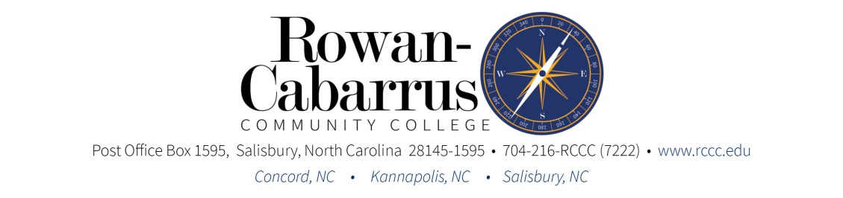
High School Counselor Reference Form

Please complete and return with student application packet by Friday, March 27th.

- Attendance: Number of full-day absences this school year:
- Tardiness: Number of unexcused tardies this school year:
- Discipline: Number of Infractions: _________
Explanation:

Signature: Date:
School Counselor

Highly Recommend ___________
Recommend ___________
Do Not Recommend ___________

**Please place the completed Guidance Counselor Reference Form in a signed and sealed envelope before returning it.
Max Points Awarded = 30 (will be awarded by program faculty based on above)

Rowan-Cabarrus Community College
Nurse Aide Certificate Application Short Answer Rubric Max Points Awarded = 50

Criteria | Exemplary | Satisfactory | Needs improvement | Unsatisfactory | Score
The following criteria will be used to evaluate the applicant’s short answer response:  Short Answer Number:  ___________________________ | 25 Points  - Exceeds expectations as outlined in the short answer response criteria.  - Consistently does all or almost all of the following: | 15 Points  - Meets expectations by fully addressing the short answer criteria.  - Does most or many of the following: | 5 Points  - Does not fully meet expectations by incompletion or failure to fully address the essay criteria.  - Does most or many of the following: | 0 Points  - Does not meet expectations based on the essay criteria.  - The assignment is not submitted.  - Consistently does all or almost all of the following:
Short Answer Response Components  The completed short answer response contains the following components:  - Goals and expectations you desire to achieve  - How Nurse Aide certificate will help student achieve goals | - All components are included in the completed paper, fully described, and are clearly written. | - All components are included and but lack a clear description of the component for the reader. | - One (1) component is missing and/or the paper is poorly described and unclear to the reader. | - Two (2) or more components are missing and/or are not clearly described.
Text  - The short answer response is a carefully written paper with appropriate use of grammar, spelling, and punctuation.  - The short answer response should be typed.  - The font is 12 pt. Times New Roman  - The body of the text is double-spaced.  - The text should be no longer than eight sentences.  - Any quotes should be properly cited to prevent plagiarism. | - A well-written and organized short answer was submitted.  - The short answer response is well written with appropriate use of grammar, spelling, and punctuation.  - The short answer response was typed.  - The body of the text is no longer 8 sentences  - There is no evidence of plagiarism and/or all quotations are properly cited. | - The short answer response submitted met most all text requirements but was not well organized.  - The short answer response has a maximum of 1-2 grammatical, spelling, and/or punctuation errors.  - There is no evidence of plagiarism and/or all quotations are properly cited. | - The short answer response submitted was missing 1 or more text requirements and was not well organized.  - The short answer response contains more than 2 mistakes in grammar, spelling, and punctuation.  - Quotes were not properly cited and the paper showed evidence of plagiarism. | - The short answer response submitted did not meet any text requirements.  - When using quotations, evidence of plagiarism is present.  - The short answer response contains multiple mistakes in grammar, spelling, and punctuation.
Total Score:
Total Score Reviewer’s Signature Date

Summation of Total Points

Section A =
Section B =
Section C =

Total Points Awarded =
(Max points awarded) = 100

RCCC Faculty/Staff:
Date Received:
Student Signature:

